MADLA NATURAL AREA TRAILS
EB: East Bend Trail - the perfect picnic area amidst the wild cherry patch –several plinths are provided for seating. Skill level Green Diamond (easy).
WW: Warbler Way - is a loop from East Bend back to the Pavilion and East Bend again; another large wild cherry patch where the warblers are – 4-5 plinths are located there, and another plinth at the end of the trail, before crossing over to the Jon Allan Loop. Skill level Blue Diamond (medium).

Warbler Alcove – located just off Warbler Way, is appropriately named as a perfect spot for observing the Warblers.

A: Amphitheater -a separate trail off Warbler Way and Ward’s Path or from the Prairie Path; a natural seating area above and over-looking the dry creek bed.

JA: Jon Allan Loop –is named for the former Helotes Mayor, Jon Allan. Benches for seating are located amongst a diverse motto of vegetation. “Millie’s Place” (Mp) is named in honor of Jon’s faithful lab and is just off the main Loop. Skill level Black Diamond (difficult)

PP: The Prairie Path - circles the wildflower/prairie field and extends from the right of the pavilion at the Huisache tree around to the left corner of the pavilion. This will not be accessible for the handicapped. Skill level Green Diamond (easy).

WP: Ward’s Path – is named for Board of Director Bill Ward. It connects Warbler Way to Prairie Path. Skill level Blue Diamond (medium)

Overlook at the Top of the Hill – be sure to read the Madla Park History Board, located on the South Wall of the Pavilion before venturing to the top of the hill on the Jon Allan Trail. A panoramic vista of the valley and surrounding hills awaits you. The two historic structures located there are ca 1900 and 1930’s vintage.

Both the Pavilion and Hilltop Areas are available for Rental. Brick Pavers and Plinths are available for purchase. For more information contact
Grey Forest City Hall 210-695-3261 #5; visit madlapark.org or greyforest-tx.gov

Take only photos
Leave only footprints
SENATOR FRANK L. MADLA, JR. NATURAL AREA

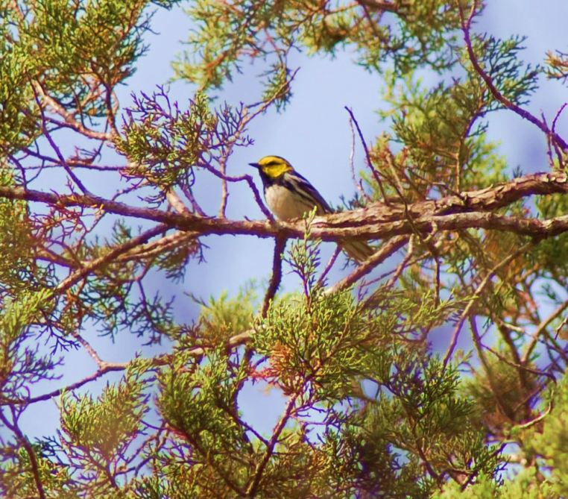
Golden-cheek Warbler Photo by Laurie Hawkins

A Facility of the City of Grey Forest
Park Hours: Sunrise to Sunset (unless otherwise posted)
Located: .5 miles east of Scenic Loop Road on Menchaca Road

Report disturbances or vandalism to Grey Forest Police: 210-684-1011
In case of Emergency call: 911 Madla Park Voicemail: 210-695-3261 #5

Purchased through a grant from Texas Parks and Wildlife Department and conservation easement funds from the City of San Antonio.

MAP
